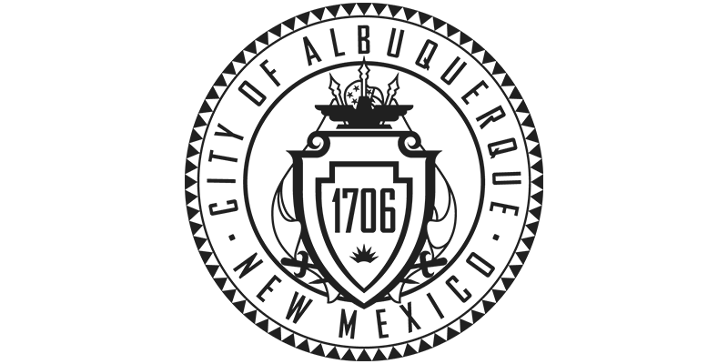City of Albuquerque Property Fact Sheet

Property ID: 101105733122510212
Legal Description: LT 5A1 BLK 2 PLAT FOR LOTS 1-A, 5-A & 7-A, BLOCK 2, YUCCAADDITION NO. 2 (BEING COMPRISED OF LOTS 1-4, 5-A & 7-A,BLOCK 2 YUCCA ADDITION NO. 2) CONT .4824 AC
Address: Old Coors NW, Albuquerque, New Mexico 87121
Acreage: 0.48
Zoning: MX-M
